Progyny Frequently Asked Questions
Below are some common questions regarding how Progyny and your fertility benefits work. If you don’t see an answer to your question, contact Progyny at 833-838-5852, Monday through Friday, 6am – 6pm PST.
What is a Smart CycleTM?
- A Smart Cycle is a complete set of fertility treatments for In-vitro fertilization (IVF), Egg Freezing or Intrauterine insemination/artificial insemination (IUI).

What is covered under a Smart Cycle?
- A Smart Cycle covers a complete set of fertility treatments for IVF, Egg Freezing or IUI including (when applicable) the consultation, diagnostic testing, monitoring and management of the fertility care, Preimplantation Genetic Screening, Intracytoplasmic sperm injection (ICSI), embryo cryopreservation, one (1) year of embryo or semen storage, anesthesiology, personalized member education and concierge service through from a Progyny Patient Care Advocate (PCA.)

Example of how I can use a Smart Cycle
- A Smart Cycle can be mixed and matched to provide coverage based on your needs. For example, a 37 year old woman with a history of miscarriage can use ½ a Smart Cycle for a frozen IVF treatment, then ½ a Smart Cycle for each frozen embryo transfer. Or a 32 year old women can use a ½ a Smart Cycle for egg freezing, and know that she can use her remaining ½ cycle if she experiences infertility some day in the future. A woman requiring IUI can use her Smart Cycle for 4 IUI attempts. See below for examples of Smart Cycle treatment values:
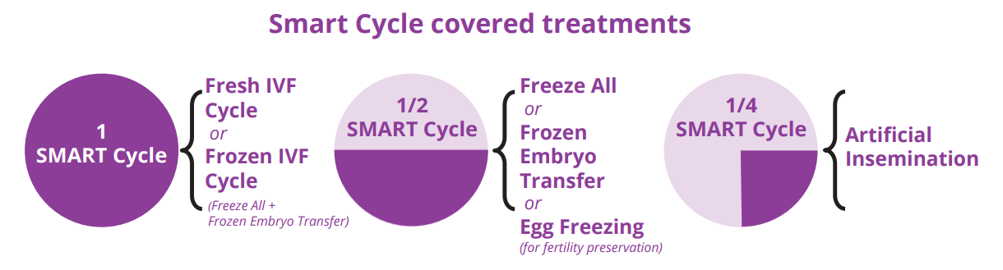

Is there a lifetime maximum for my fertility services?
- There is a lifetime maximum of two (2) Smart Cycles offered by your employer. There is no benefit dollar limit, which allows you the peace of mind in knowing that your entire Smart Cycle will be covered, rather than exhausting insurance coverage mid-treatment. Plus, a Smart Cycle covers technologies and diagnostic tests that a patient normally must pay out-of-pocket, so you receive more value and coverage.

Can I use any fertility doctor?
- In order to provide the most effective care, you will need to seek services from one of Progyny’s vast network of providers. To start the process of finding a fertility specialist near you, contact Progyny at 833-838-5852.

How do I get started?
- To get started, contact Progyny at 833-838-5852.

I’m in the middle of fertility treatment under my Cigna medical coverage. Will my treatment be covered after January 1st?
- If you started your treatment prior to January 1st but will not complete your treatment until after January 1st, transition of coverage may be approved for you. Please contact Progyny at 833-838-5852.

Will I have to undergo other treatment prior to pursuing IVF Treatment?

- No, the Progyny Smart Cycle benefit approach provides comprehensive coverage for all fertility treatments, thereby removing the need for precertification. Progyny’s philosophy is to provide doctors the flexibility to provide the most effective treatment, the first time.

Will Kaiser HMO plan members have access to the Progyny Fertility Smart Cycle Benefit?
- No, only Collective Health plan members on the Anthem HSA and Anthem HRA will have access to the Progyny Fertility Smart Cycle Benefit.

What is the difference between my current Cigna fertility benefits and the new fertility benefits through Progyny?

Cigna | Progyny
$15k per lifetime | 2 Smart Cycles per lifetime
PGS is not a covered service | PGS is covered
No elective egg freezing benefit | Covers elective egg freezing
90% member coverage | 90% member coverage
No access to Patient Care Advocate (PCA) concierge support | Access to Patient Care Advocate (PCA) concierge support

Will I receive an insurance card from Progyny?
- No. However, Progyny will provide a confirmation statement when we authorize your services. Your confirmation statement is your proof of enrollment and will include your Progyny member ID, authorization number and a list of in-network laboratories for diagnostic testing, Preconception Carrier Screening and Preimplantation Genetic Screening (PGS).

What insurance information should I provide to my network fertility clinic and lab?
- Please provide your Progyny confirmation statement.

What is my out of pocket responsibility?
- Once you have met your medical plan deductible through your Collective Health medical coverage, authorized fertility services will be covered at 90%. You will be responsible for 10% of the cost.

When do I pay my out of pocket responsibility?
- Once your fertility treatment ends, you will receive an explanation of benefits (EOB) from Collective Health outlining your out of pocket responsibility. You will also receive an invoice from Progyny for your out of pocket responsibility, which will be due upon receipt.

Are fertility medications covered under the plan? Do I need a pre-authorization for fertility medications?
- Express Scripts is your pharmacy vendor. Please contact Progyny at 833-838-5852 for any questions.

How much will my medications cost?
- Please contact Progyny at 833-838-5852 for any questions related to your out-of-pocket responsibility.

Do I need a referral for treatment?
- Yes. To begin treatment, a member must contact Progyny at 833-838-5852 to get started.

Is surrogacy covered?
- If you are considering pursuing surrogacy as a family-building option, some procedures may be covered under your Progyny benefit. Please contact Progyny at 833-838-5852 to learn more.

